CSS 311 Parallel and Distributed Computing

Parallel Implementation of Medical Image Processing

Name 1: Albin John Roll No: 2023BCD0005
Name 2: Rupsika Thipparthi Roll No:2023BCS0197

Course Instructor: Dr. John Paul Martin

Department of Computer Science Indian Institute of Information Technology Kottayam

Date of Submission: [09/10/2025]

Project Abstract

The project Parallel implementation of medical image processing focuses on medical preprocessing tasks using Open MP parallelization. In traditional methods it is doing the preprocessing tasks like grayscale conversion, negative transformation and edge detection sequentially. This will lead to longer processing time for high resolution medical images.

This issue can be solved by parallelizing, we will distribute pixel wise computations across multiple threads. Each stage of processing like loading, transforming, and filtering is optimized to run concurrently without race conditions.

The Comparison between execution time of serial code and parallel code shows that the parallel code is 3 times faster for 6 image samples we took. If we increase the number of images and resolution of the image into a much higher value, the difference will be huge. This improvement enables faster preprocessing for diagnostic applications where timely image analysis is important.

1) Introduction

Medical image processing plays a major role in Modern Healthcare.
It's useful for Doctors , Radiologists for diagnosis purposes and for treating several diseases.There are many techniques such as MRIs , Xray, CT scanning
To get a useful information from these techniques like identifying tumors,tissue boundaries many image processing algorithms like Negative Transformation and Edge detection are used.Usually it takes a more execution time without
Parallelising it because of its large size and high precision. The negative transformation is used to enhance visual contrast and highlight certain structures, whereas Sobel edge detection could highlight the boundaries and edges that could represent regions as tumors.

Parallel and distributed computing provide an efficient solution by dividing the work across multiple processor cores, thereby reducing execution time. This project speeds up image processing tasks, making it suitable for large scale diagnosis, especially in medical field time is a very important factor.

2. Literature Survey

1. Negative Transformation (Image Inversion)

Standard Serial Approach
The negative transformation is one of the simplest intensity transformation functions in digital image processing. The classical approach involves pixel-by-pixel operation with the formula: s = (L-1) - r, where s is output intensity, r is input intensity, and L is the maximum intensity level (256 for 8-bit images).
- Gonzalez & Woods (2018) present this as a fundamental point processing operation
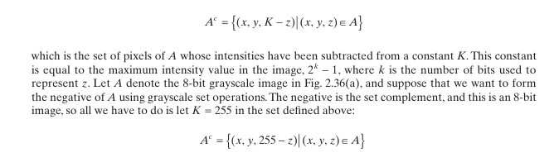

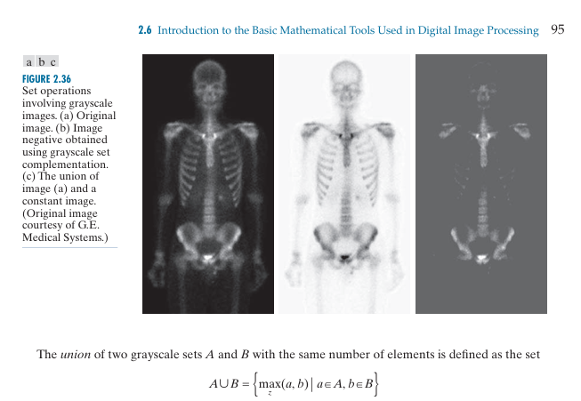
*(Screenshots proofs from the book named Digital Image Processing FOURTH EDITION Rafael C. Gonzalez • Richard E. Woods )
- Time complexity: O(n×m) where n×m are image dimensions
- It is parallelizable due to pixel independence

Limitations of Serial Implementation:
- Sequential processing becomes time-consuming for high-resolution images (e.g., 4K: 8.3 million pixels)
- Inefficient memory access patterns

2. Sobel Edge Detection

Standard Serial Approach
The Sobel filter consists of two 3×3 convolution kernels: one for detecting changes in the horizontal direction and the other in the vertical direction. These kernels compute the gradient of the image intensity at each pixel, highlighting the edges
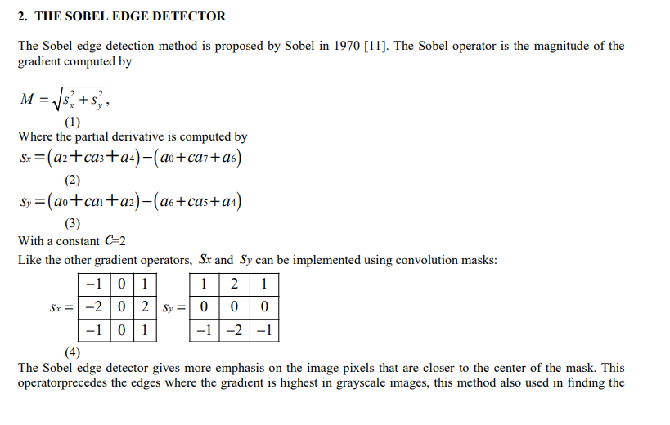
*(A screenshot from the paper publication by Neha Mathura,Shruti Mathur ,Divya Mathur named A Novel Approach To Improve Sobel Edge Detector)
Classical Algorithm:
- Apply horizontal gradient mask (Gx)
- Apply vertical gradient mask (Gy)
- Compute gradient magnitude: G = √(Gx² + Gy²)
- Apply threshold for edge binary map
Time Complexity: O(n×m×k²) where k is kernel size (3×3 for Sobel)

3. Problem Statement and Objectives

3.1 Problem Definition

The Project take Raw Medical images as input and convert them into negative and Edge Detected images since Negative images enhance contrast by making light areas as dark and vice versa whereas Edge detection images highlight the boundaries and shapes of anatomical structures.All these operations are repetitive pixel computations so they can be parallelized by using Openmp for faster execution.

3.2 OBJECTIVES:

- To collect medical images dataset for preprocessing.

- To Implement Serial solution for creating Negative Transformation Images and Edge detection on medical images.

- To Identify parallelizable code from serial.

- To Implement Parallelized Solution for creating Negative Transformation Images and Edge detection on medical images.

- To analyze and compare performance and scalability.

4. Methodology and System Architecture

Flowchart For Serial Implementation
START
main()

Valid Input?
Arg >= 2

Load Image
stbi_load()-->grayscale

Yes

EXIT

No
Load Success?
img != NULL

NO
YES
ERROR
Exit(2)
Convert Data
Uchar ->int matrix

Image Processing Pipeline

Negative: 255 - pixel_value
Sobel: √(Gx² + Gy²)

Negative
Transform
Sobel Edge
Detection

Save Results
Negative / Edge
Show Timings
Performance metrics
END
Return 0

Flowchart For Parallel Implementation
Start
Initialize Image List
Create Output Directories(negative/,edge/)

Parallel Zone-OpenMP
#pragma omp parallel for BATCH IMAGE PROCESSING schedule(dynamic)
Thread 1
Thread 2
Thread 3
Thread 4
For Each Image (idx)
Extract Base Name
Load PNG Image as grayscale
Image Loaded Successfully?

#pragma omp critical
Print Image Loaded
#pragma omp parallel for collapse(2)
Convert 1D → 2D Array
#pragma omp parallel for collapse(2) Negative Transformation
New = 255 - old
Save Negative Image
negative/imageX.png
Initialize Gx,Gy kernels
3*3 Sobel Operators

YES

#pragma omp parallel for collapse(2)
SOBEL EDGE DETECTION
Magnitude = sqrt sumX^2 + sumY^2
Save Edge-Detected Image
edge/imageX.png
Free Image Memory
stbi_image_free()
#pragma omp critical
Print Success Message
Increment totalProcesses

Stop Timer
Calculate Execution Time
Display Total Images Processed and Total Execution Time
End

4.1 Serial Algorithm :
Start timer
Initialize list of input image filenames
Create output folders: “negative” and “edge”

For each image file in the list:
Load image in grayscale mode
If image not loaded:
Print error and continue to next file

Convert 1D image array to 2D matrix

// Negative Transformation
For each pixel (i, j) in image:
negative_pixel = 255 - image[i][j]
Save the negative image to “negative” folder

// Sobel Edge Detection
Define Gx and Gy convolution kernels
For each pixel (i, j) excluding border:
sumX = sumY = 0
For m = -1 to 1:
For n = -1 to 1:
sumX += image[i+m][j+n] * Gx[m+1][n+1]
sumY += image[i+m][j+n] * Gy[m+1][n+1]
magnitude = sqrt(sumX² + sumY²)
If magnitude > 255:
magnitude = 255
edgesData[i][j] = magnitude
Save the edge image to “edge” folder

Free the memory of the current image
Increment total processed count

Stop timer
Print total number of images processed and total execution time
End

4.2 Parallel Algorithm (OpenMP):
Start timer
Initialize list of input image filenames
Create output folders: “negative” and “edge”

#pragma omp parallel for reduction(+:totalProcessed) schedule(dynamic)
For each image file in the list:
Load image in grayscale mode
If image not loaded:
Print error and continue

Convert 1D image array to 2D matrix
#pragma omp parallel for collapse(2)
For each pixel (i, j):
image[i][j] = grayscale value

// Parallel Negative Transformation
#pragma omp parallel for collapse(2)
For each pixel (i, j):
negative_pixel = 255 - image[i][j]
Save negative image to “negative” folder

// Parallel Sobel Edge Detection
Define Gx and Gy kernels
#pragma omp parallel for collapse(2)
For each pixel (i, j) excluding border:
sumX = sumY = 0
For m = -1 to 1:
For n = -1 to 1:
sumX += image[i+m][j+n] * Gx[m+1][n+1]
sumY += image[i+m][j+n] * Gy[m+1][n+1]
magnitude = sqrt(sumX² + sumY²)
If magnitude > 255:
magnitude = 255
edgesData[i][j] = magnitude
Save edge image to “edge” folder

Free memory of current image
Increment total processed count
Stop timer
Print total number of images processed and total execution time
End

4.3 Implementation Details
Programming Language: C/C++
Platform: Windows
Compiler: GCC (-fopenmp)
Hardware Configuration: CPU: Intel Core i5 / i7 or equivalent
Cores/Threads: 4–8 (depending on the system)
RAM: 8 GB or higher
Disk: SSD recommended for faster I/O operations

5. Results and Analysis

Serial Output:
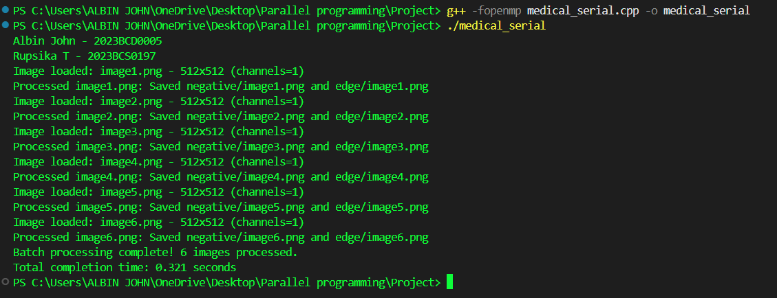
Parallel Output:
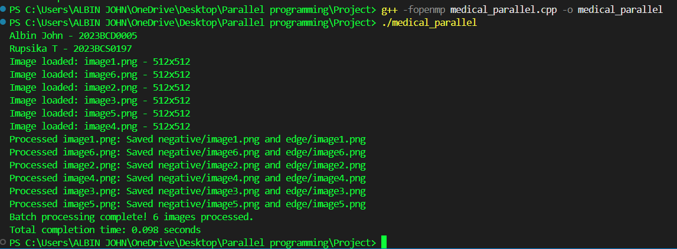
Test Case 1:
Input:
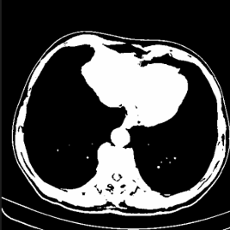
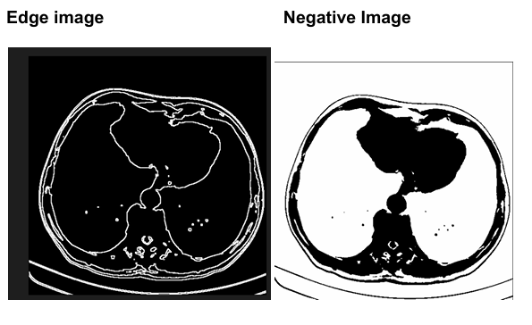
Test Case 2:
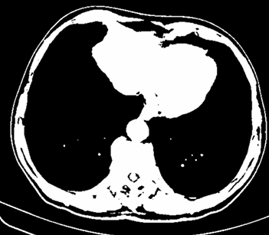
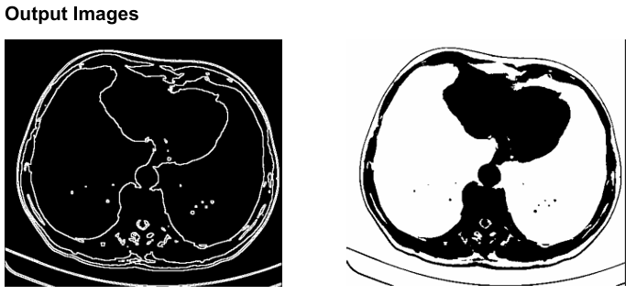
Test Case 3:
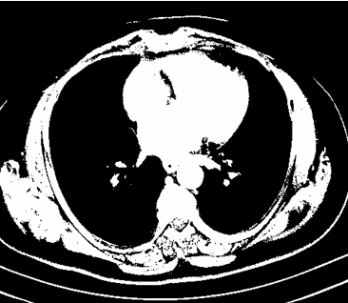
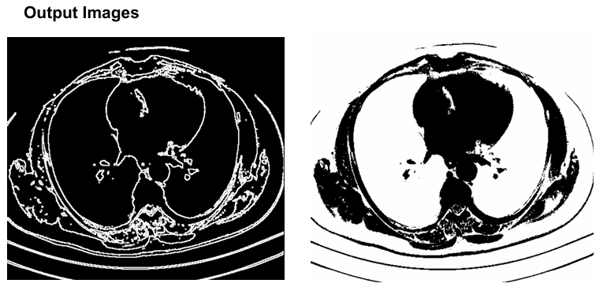

Performance Comparison Table:
Implementation | Execution Time (seconds) | SpeedupT
Serial | 0.321 | 1×
Parallel (OpenMP) | 0.098 | 3.28×
Speedup = Serial Time / Parallel Time = 0.321 / 0.098 ≈ 3.28

Time Complexity Analysis:
Negative Transformation:
Each pixel is processed independently → O(H × W)
H = image height, W = image width
Sobel Edge Detection:
Each pixel (excluding border) requires a 3×3 convolution → O(H × W × 9) ≈ O(H × W)
Batch Processing (N images):
Total complexity ≈ O(N × H × W)

Scalability
Execution time is reduced by parallelizing code with OpenMp
Speedup is mainly depends on the number of CPU cores and memory.
Usually images of large size,for more number of images have very good Scalability because pixel wise operations are highly parallelizable
Some overhead occurs due to thread creation and I/O operations, but it is negligible for larger number of images and for larger batches.
6. Discussion and Observations
This implementation shows a significant improvement in performance when using OpenMP parallelization. For a batch of six images, the serial execution time was 0.321 seconds, while in the parallel version completed in 0.098 seconds, acquiring a speedup of 3.28×.
This shows that independent pixel-wise operations, such as negative transformation and Sobel edge detection, are highly efficient when parallelization.

Limitations
Here we are parallelizing the number of images processed simultaneously, But we are not parallelizing the edge detection and negative transformation per image,
For example, Image 1, Image 2, Image 3 all are executing parallely. But if we go inside image 1 after completing negative transformation only it is doing edge detection, these both transformations are not doing simultaneously even though these both are not dependent . If we can parallelize it we can improve the efficiency much higher.
But the problem we are facing is when we try to parallelize it, the whole code is executing in thread 0, Because the nested parallelization is not supported in openMP. The execution time is getting larger when we tried to solve that issue using AI.

7. Conclusion and Future Scope
In this project, a medical image processing pipeline was implemented to carry out grayscale conversion, negative transformation, and Sobel edge detection on batches of PNG images. A serial implementation was initially done followed by an OpenMP-based parallel version with a speedup of 3.28× for six sample images. The parallel implementation performs effective pixel-wise distribution across several CPU cores with superior execution time and scalability for larger data.
Future Scope:Appendix A. Serial Code and Output B. Parallel Code (OpenMP) and Output
The project can be extended to MPI in a way that large-scale medical image analysis is possible on multiple machines for a broader area.
CUDA acceleration of GPU could also decrease computation time specifically for high resolution images and real time use.
Other preprocessing methods such as noise removal, histogram equalization and adaptive thresholding may be incorporated to enhance medical diagnostic precision.
This project serves as a foundation for scalable and effective medical image preprocessing pipelines that are applicable in research and clinical pipelines.

8. References:
- Digital Image Processing FOURTH EDITION Rafael C. Gonzalez • Richard E. Woods -
Digital Image Processing, 4e
- Paper publication by Neha Mathura,Shruti Mathur ,Divya Mathur named A Novel Approach To Improve Sobel Edge Detector
A Novel Approach to Improve Sobel Edge Detector - ScienceDirect
- A Descriptive Algorithm for Sobel Image Edge Detection, O. R. Vincent, O. Folorunso
https://proceedings.informingscience.org/InSITE2009/InSITE09p097-107Vincent613.pdf

Appendix
A. Serial Code
#define STB_IMAGE_IMPLEMENTATION
#define STB_IMAGE_WRITE_IMPLEMENTATION
#include "stb_image.h"
#include "stb_image_write.h"

#include <iostream>
#include <vector>
#include <cmath>
#include <filesystem>
#include <string>
#include <cstring>
#include <omp.h>
using namespace std;

int main() {
cout << "Albin John - 2023BCD0005\n";
cout << "Rupsika T - 2023BCS0197\n";
double start_time = omp_get_wtime();

// List of input image filenames
vector<string> inputFilenames = {"image1.png", "image2.png", "image3.png","image4.png","image5.png","image6.png"}; // Add more as needed

// Create output folders if they don't exist
std::filesystem::create_directory("negative");
std::filesystem::create_directory("edge");

int totalProcessed = 0;
for (const auto& inputFilename : inputFilenames) {
int width, height, channels;

// Extract base filename (without path)
string inputPath(inputFilename);
size_t pos = inputPath.find_last_of("/\\");
string baseName = (pos == string::npos) ? inputPath : inputPath.substr(pos + 1);

// Load PNG (converted to grayscale)
unsigned char* img = stbi_load(inputFilename.c_str(), &width, &height, &channels, 1);
if (!img) {
cerr << "Error: Could not load " << inputFilename << "\n";
continue;
}

cout << "Image loaded: " << inputFilename << " - " << width << "x" << height << " (channels=" << channels << ")\n";

// Convert to 2D vector
vector<vector<int>> image(height, vector<int>(width));
for (int i = 0; i < height; i++) {
for (int j = 0; j < width; j++) {
image[i][j] = img[i * width + j]; // grayscale value (0–255)
}
}

// Negative transformation
vector<unsigned char> negativeData(width * height);
for (int i = 0; i < height; i++) {
for (int j = 0; j < width; j++) {
negativeData[i * width + j] = 255 - image[i][j];
}
}
string negativePath = "negative/" + baseName;
stbi_write_png(negativePath.c_str(), width, height, 1, negativeData.data(), width);

// Sobel edge detection
int Gx[3][3] = { {-1,0,1}, {-2,0,2}, {-1,0,1} };
int Gy[3][3] = { {-1,-2,-1}, {0,0,0}, {1,2,1} };

vector<unsigned char> edgesData(width * height, 0);
for (int i = 1; i < height - 1; i++) {
for (int j = 1; j < width - 1; j++) {
int sumX = 0, sumY = 0;
for (int m = -1; m <= 1; m++) {
for (int n = -1; n <= 1; n++) {
int pixel = image[i+m][j+n];
sumX += pixel * Gx[m+1][n+1];
sumY += pixel * Gy[m+1][n+1];
}
}
int mag = sqrt(sumX*sumX + sumY*sumY);
if (mag > 255) mag = 255;
edgesData[i * width + j] = mag;
}
}
string edgePath = "edge/" + baseName;
stbi_write_png(edgePath.c_str(), width, height, 1, edgesData.data(), width);

cout << "Processed " << inputFilename << ": Saved " << negativePath << " and " << edgePath << "\n";
stbi_image_free(img);
totalProcessed++;
}
double end_time = omp_get_wtime();
cout << "Batch processing complete! " << totalProcessed << " images processed.\n";
cout << "Total completion time: " << (end_time - start_time) << " seconds\n";
return 0;
}

Output

B. Parallel Code (OpenMP)

#define STB_IMAGE_IMPLEMENTATION
#define STB_IMAGE_WRITE_IMPLEMENTATION
#include "stb_image.h"
#include "stb_image_write.h"

#include <iostream>
#include <vector>
#include <cmath>
#include <filesystem>
#include <string>
#include <omp.h>
using namespace std;

int main() {
double start_time = omp_get_wtime();
cout << "Albin John - 2023BCD0005\n";
cout << "Rupsika T - 2023BCS0197\n";

// List of input images
vector<string> inputFilenames = {"image1.png", "image2.png", "image3.png", "image4.png", "image5.png", "image6.png"};

// Create output folders
std::filesystem::create_directory("negative");
std::filesystem::create_directory("edge");

int totalProcessed = 0;

#pragma omp parallel for reduction(+:totalProcessed) schedule(dynamic)
for (int idx = 0; idx < inputFilenames.size(); idx++) {
const string& inputFilename = inputFilenames[idx];
int width, height, channels;

// Extract base name
size_t pos = inputFilename.find_last_of("/\\");
string baseName = (pos == string::npos) ? inputFilename : inputFilename.substr(pos + 1);

// Load PNG as grayscale
unsigned char* img = stbi_load(inputFilename.c_str(), &width, &height, &channels, 1);
if (!img) {
#pragma omp critical
cerr << "Error: Could not load " << inputFilename << "\n";
continue;
}

#pragma omp critical
cout << "Image loaded: " << inputFilename << " - " << width << "x" << height << "\n";

// Convert to 2D vector
vector<vector<int>> image(height, vector<int>(width));
#pragma omp parallel for collapse(2)
for (int i = 0; i < height; i++) {
for (int j = 0; j < width; j++) {
image[i][j] = img[i * width + j];
}
}

//

vector<unsigned char> negativeData(width * height);
#pragma omp parallel for collapse(2)
for (int i = 0; i < height; i++) {
for (int j = 0; j < width; j++) {
negativeData[i * width + j] = 255 - image[i][j];
}
}
string negativePath = "negative/" + baseName;
stbi_write_png(negativePath.c_str(), width, height, 1, negativeData.data(), width);

int Gx[3][3] = { {-1,0,1}, {-2,0,2}, {-1,0,1} };
int Gy[3][3] = { {-1,-2,-1}, {0,0,0}, {1,2,1} };

vector<unsigned char> edgesData(width * height, 0);
#pragma omp parallel for collapse(2)
for (int i = 1; i < height - 1; i++) {
for (int j = 1; j < width - 1; j++) {
int sumX = 0, sumY = 0;
for (int m = -1; m <= 1; m++) {
for (int n = -1; n <= 1; n++) {
int pixel = image[i+m][j+n];
sumX += pixel * Gx[m+1][n+1];
sumY += pixel * Gy[m+1][n+1];
}
}
int mag = sqrt(sumX*sumX + sumY*sumY);
if (mag > 255) mag = 255;
edgesData[i * width + j] = mag;
}
}
string edgePath = "edge/" + baseName;
stbi_write_png(edgePath.c_str(), width, height, 1, edgesData.data(), width);

stbi_image_free(img);

#pragma omp critical
{
cout << "Processed " << inputFilename << ": Saved " << negativePath << " and " << edgePath << "\n";
totalProcessed++;
}
}

double end_time = omp_get_wtime();
cout << "Batch processing complete! " << totalProcessed << " images processed.\n";
cout << "Total completion time: " << (end_time - start_time) << " seconds\n";

return 0;
}

Output


Thank You !!

